 | 'Fourth Option' - investment to improve existing and build a new generation of first class council housing
Press Statement for immediate release (08 Mar 2010 12:26)
MPs demand action on council housing finance reforms

  A senior MP says Government delay in producing detail of financial reforms is 'unacceptable' and leaves some authorities facing 'a dire funding crisis'.
  Austin Mitchell MP, chair of the House of Commons Council Housing Group, in a letter to Housing Minister John Healey demands 'a firm date for the publication of your proposals to Reform council housing finance, and an assurance that these proposals will ensure funding reform provides resources to ensure that every council home and estate is improved and permanently maintained'
  Details of the long-awaited Council Housing finance reforms are still under wraps, although details were expected last month. Council housing directors, and Authorities Retaining Council Housing have had to postpone planned meetings to discuss the proposals. Reforms are overdue after an 18-month government Review found large-scale underfunding of council housing management and repair budgets.
  Ministers promised ‘a sustainable, long term system for financing council housing’ when the Review was launched in 2007. The National Audit Office warned in January that ‘Unless a plan is put in place to appropriately fund housing repairs, there remains a risk that a backlog will again build up, reducing the value for money of what has been achieved so far.’ (NAO, The Decent Homes Programme Jan 2010).
  Austin Mitchell MP says:
  'Fair funding for council housing is urgently needed, along with a massive programme of new council house building. It is not acceptable for Government to stall any longer on putting right the underfunding crisis. Council housing is essential to provide homes for the 5 million on council waiting lists, and all those the private housing market is failing to provide for.'
  DCH national conference 19th March will discuss latest details of government's reform proposals, and a tenants' Manifesto for Council Housing.
  Notes
  See full DCH conference programme.
  DCH is inviting entries for a Positively Council Housing exhibition with photos, paintings, drawings or any other visual images capturing the real life of council tenants.
  To stop getting DCH press releases reply with UNSUBSCRIBE in subject.
  For background information on the demand for the 'Fourth Option' for council housing and who supports the campaign see www.defendcouncilhousing.org.uk
  
  New campaign newspaper
  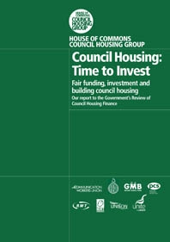
  House of Commons Council Housing Group report of inquiry to government's 'Review of Council Housing Finance'
  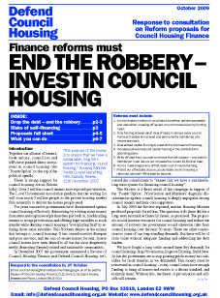
  DCH Detailed Response to Review Proposals
  Find out on our new web page how your council has responded to the government's proposals.
  Affiliate and donate

