 | 'Fourth Option' - investment to improve existing and build a new generation of first class council housing
Conference to review delayed reform announcement - Exhibition and other Events

  Full details of Government proposals to reform council housing finance have not yet been released, but an outline announcement is expected next month. DCH National Conference on 19th March will be an essential date for information and analysis of what is being offered and initial reactions.
  The full conference programme is now available. Download and print the programme, use it to book your place and to encourage others from your area to attend.
  DCH is inviting entries for a Positively Council Housing exhibition at our national conference.
  We want photos, paintings, drawings or any other visual images that capture the real life of council tenants, not the negative stereotypes. We’re looking for the positive side of life in council housing, including architecture, nurseries and other facilities, community events and activities; gardens, art and projects.
  Tenants, union members, organisations and campaigners can send entries to ‘DCH Exhibition’ by post (to address on booking form) or email to info@defendcouncilhousing.org.uk We will display as many as possible at the TUC Centre.
  Events Coming Up
  DCH will be leafleting at the following events - if you can help or will be attending let us know.
  Right to work lobby
  28 February Brighton
  Trade Union Coordinating Group
  Sat 6th March - PCS London
  ARCH meeting on self-financing
  Wed 10 March at LGA, Smith Square, London SW1
  Inside Housing Question Time
  Wed 10 March Central Hall Westminster, London
  Local Councils Meeting
  Friday 12 March at LGA, Smith Square, London SW1
  Unions 21
  16 March - TUC London]
  The new DCH campaign newspaper is still available.
  To stop getting DCH press releases reply with UNSUBSCRIBE in subject.
  For background information on the demand for the 'Fourth Option' for council housing and who supports the campaign see www.defendcouncilhousing.org.uk
  
  New campaign newspaper
  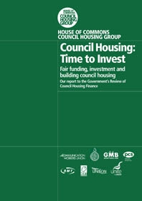
  House of Commons Council Housing Group report of inquiry to government's 'Review of Council Housing Finance'
  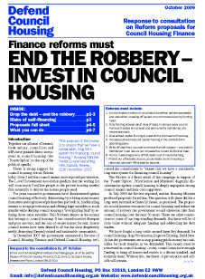
  DCH Detailed Response to Review Proposals
  Find out on our new web page how your council has responded to the government's proposals.
  Affiliate and donate

