 | 'Fourth Option' - investment to improve existing and build a new generation of first class council housing
Book Now for DCH national conference 19 March

  DCH National Conference 19th March at the TUC conference centre, central London. Contributors confirmed so far include
  Austin Mitchell MP; Shelter; APSE; Leeds Tenants Federation; Steve Partridge CIH Heather Wakefield (Unison); Jack Dromey (Unite); Prof Peter Ambrose...
  Print off and return this leaflet, to book places, and circulate to local tenant groups, trade unions, councillors and others. Organise a joint delegation and remember to book your transport now for cheap deals.
  The new DCH campaign newspaper is still available. Eight pages make the case against transfer and for direct investment; analyse the government's new proposals; and explain why we need new first-class, affordable, council housing with secure tenancies, not more public-private partnerships.
  Order enough to circulate in your area. Ask your council for funding – they always claim they want tenants to be well-informed. Bulk orders £20 per 100; £120 per 1,000.
  A number of councils, including some with ALMOs, are still trying to privatise council housing (find out who's doing what ).
  If you’re campaigning for investment in existing and new council housing, or facing transfer, demolition or PFI, use the campaign newspaper and resources on our website. And bring tenants, sympathetic councillors and union reps to our conference.
  To stop getting DCH press releases reply with UNSUBSCRIBE in subject.
  For background information on the demand for the 'Fourth Option' for council housing and who supports the campaign see www.defendcouncilhousing.org.uk
  
  New campaign newspaper
  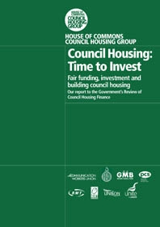
  House of Commons Council Housing Group report of inquiry to government's 'Review of Council Housing Finance'
  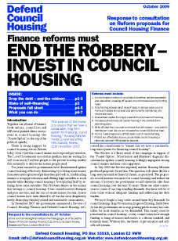
  DCH Detailed Response to Review Proposals
  Find out on our new web page how your council has responded to the government's proposals.
  Affiliate and donate

