

17th December 2002

Dear Colleague,
National Rally and Lobby of Parliament
WEDNESDAY 29th JANUARY 2003, 1-3 PM, WESTMINSTER CENTRAL HALL
The campaign to secure the future of council housing is gathering strength, and we are writing to ask you to join us in London on 29th January to show our united determination to defend this vital public service.
It is no exaggeration to say that the future of council housing could be decided in the course of this winter. Crucial decisions will be announced in January in the Deputy Prime Minister’s ‘Communities Plan'. Tony McNulty, Under Secretary of State has urged critics to “take part in the full debate that will unfold from mid-January”.
As growing numbers of tenants reject stock transfer, the government is rethinking its approach to housing. Our united campaign is bringing together increasing numbers of tenants, trade unions, councillors and MPs against privatisation and in favour of direct investment in council housing without any strings.
This rally and lobby of Parliament will urge the Government to create a ‘level playing field’ by removing discrimination against council housing. This is a principle that unites of all who are committed to winning a secure long term future for council housing and is the best way to ensure that repairs and improvements are done and new homes built.
The rally and lobby will focus on the key measures needed to make this happen:
- end all ‘Daylight Robbery’ tax on tenants’ rents
- free councils to borrow for investment
- return all capital receipts to fund investment in our homes
- write-off all HRA debt – not just for councils who transfer
- fund council borrowing through an investment allowance
- use Local Authority Social Housing Grant to build new council homes

Sponsors of the lobby already include Tenants Federations in Newcastle, Stockport, Doncaster, Liverpool, Hull, Wakefield, Camden, Wirral and Southwark, the trade unions UNISON, UCATT, GMB, T&G and Defend Council Housing.
For further information and details of transport arrangements contact your local tenants organisation, trade union branch or Defend Council Housing PO Box 33519, London E8 4XW phone 020 7987 9989 email info@defendcouncilhousing.org.uk websites www.defendcouncilhousing.org.uk/ www.unison.co.uk www.gmb.org.uk www.ucatt.org.uk www.tgwu.co.uk

Our joint campaigning is already seeing positive results. Please come to London on 29th and join tenants, trade unionists, MPs and councilors from around the country

PTO

for the rally at Central Hall Westminster. Contact your local MPs to ask them to meet you on the day and to support Early Day Motion 116 on Council Housing which embodies the lobby demands.

Contact local tenants’ organisations or trade unions to co-ordinate arrangements, and see www.defendcouncilhousing.org.uk for the latest transport and other information.

Yours fraternally, (on behalf of lobby organisers)

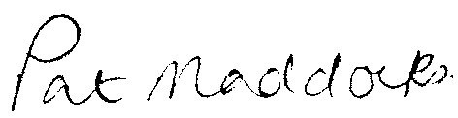

Austin Mitchell MP Alan Walter Pat Maddocks
Rally Chair Defend Council Housing Liverpool Tenants Fed

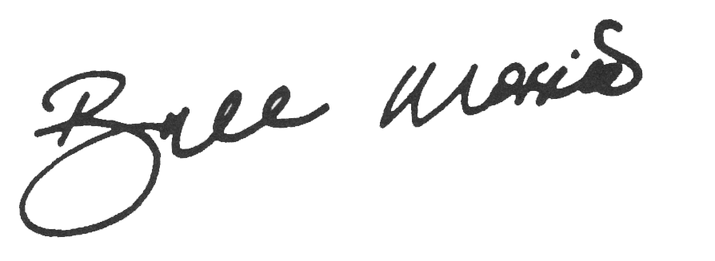
Dave Prentis John Edmonds George Brumwell Bill Morris
General Secretary General Secretary General Secretary General Secretary
UNISON GMB UCATT TGWU

For further information and details of transport arrangements contact your local tenants organisation, trade union branch or Defend Council Housing PO Box 33519, London E8 4XW phone 020 7987 9989 email info@defendcouncilhousing.org.uk websites www.defendcouncilhousing.org.uk/ www.unison.co.uk www.gmb.org.uk www.ucatt.org.uk www.tgwu.co.uk

