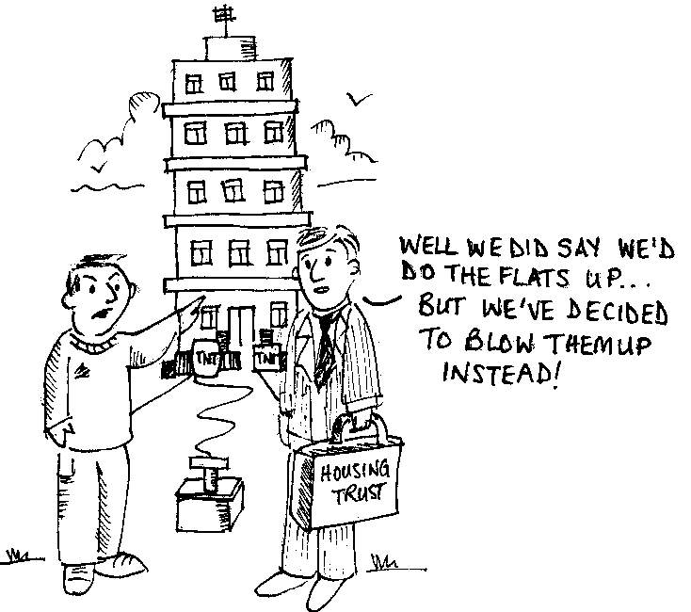

(after stock transfer)

79%
WORSE
or no better
21%
BETTER
Source: Customer Satisfaction Survey,
New Charter Housing Trust
(Annual Report 2001)

“Editor – It will be two years in April since New Charter Housing Trust took over the running of Tameside Council’s housing stock and I must admit, they’ve lived up to my expectations. Just as I expected, nothing has been done.
Where are the new bathroom suites and kitchens we were promised before the ‘Big Switch’?
Thousands of pounds must have been spent on the glossy brochures urging us to vote for this takeover… It just reminded me of why I voted no in the first place.”

The following is an extract of a letter in the Tameside Advertiser on 16th January 2002 from an angry Denton resident. It is typical of many similar letters:
“Liverpool’s high rise tenants voted enthusiastically for a Housing Action Trust (HAT) in 1992 on the expectation that their flats were to be refurbished. They enjoyed their flats and co-operated together as communities. There is no doubt that HAT would have been rejected in the ballot had it declared its intention to demolish the flats.”
(Evidence given by residents in Liverpool to the House of Commons Urban Affairs Select Committee in its recent Housing Inquiry.)

- Harrogate Council has shelved its plans to sell its housing stock. The Council had overestimated the amount of work needed to bring its stock up to standard by £8.5 million.
- A Police investigation is being conducted at Willow Park Trust in Wythenshawe, which involves at least £170,000 of missing money.
- The District Auditor found that Bath & North East Somerset Council used biased literature in consultations on stock transfer.
- In Manchester and Southwark allegations of “rigging” the ballot and pressurising tenants to vote ‘yes’ have been made.
- The Housing Corporation has intervened into the running of the Ridgehill Housing Association following problems with the Board. Ridgehill was also involved in a failed scheme to buy homes in Spain and offer them to its elderly tenants.

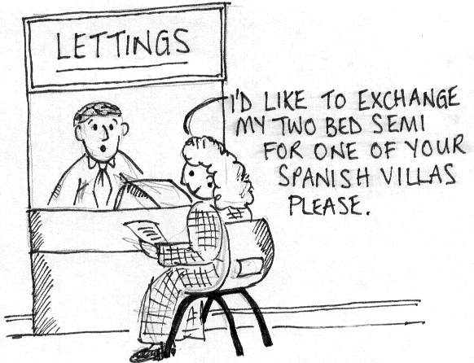
Letter to tenants from Chief Executive before transfer:
“An average of £12,500 will be spent on improving every home.”
Big Switch newsletter before transfer:
“What can £12,500 buy – New kitchen . etc….”
Letter from New Charter after tenant asked about new
kitchen following transfer:
“Your letter suggested that the tenant had been “promised” a new kitchen. No such assurance has been given…..I can only assume that she may be referring to New Charter’s long-term commitment to upgrade kitchens and bathrooms as required”.

Hattersley housing transfer collapses due to the discoverey of a £10million shortage of cash.
31st January 2002.

